34.99: The image formed by the converging lens is 30.0 cm from the converging lens, and becomes a virtual object for the diverging lens at a position 15.0 cm to the right of the diverging lens. The final image is projected 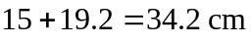 from the diverging lens.
